

Project Report (Part I)

**Deep Learning Strategies For Enhanced Time Series Forecasting**

*Submitted in partial fulfillment for the award of the degree*

*Of*

**BACHELOR OF ENGINEERING**

**INFORMATION TECHNOLOGY**

Pranav Bhavsar (Roll No.:11)

Bharat Bohra (Roll No.:12)

***Under the Guidance of***

Mrs. Pranjali Kasture

**Designation**

Assistant Professor

Deputy HOD, IT Department

**Department of Information Technology**

**(Academic Year. 2024 25)**





**CERTIFICATE**

This is to certify that the project entitled **“Deep Learning Strategies For Enhanced Time Series Forecasting”** is a bonafide work of **Pranav Bhavsar BE IT A 11, Bharat Bohra BE IT A 12,** submitted to the Thakur College of Engineering and Technology, Mumbai (An Autonomous College affiliated to University of Mumbai) in partial fulfillment of the requirement for the **Project-I** for award of the degree of **“Bachelor of Engineering”** in **“Information Technology”**.

|  |  |
| --- | --- |
| Signature with Date: -----------------Name of Guide: Ms. Pranjali Kasture  Designation: Assistant Professor  Deputy HOD, IT Department | Signature with Date: --------------------Name of HOD: Dr. Rajesh Bansode  Name of Department: Information Technology |
| Date:  Place: |  |

**Acknowledgement**

It would be unfair if I do not acknowledge the help and support given by Professors, students, friends etc.

We sincerely thank our guide Ms. Pranjali Kasturi for his/her guidance and constant support and also for the stick to our backs. We also thank the project coordinators for arranging the necessary facilities to carry out the project work.

We thank the HOD, Dr. Rajesh Bansode, the Principal, Dr. B. K. Mishra and the college management for their support.

Pranav Bhavsar (Roll No.:11)

Bharat Bohra (Roll No.:12)

TABLE OF CONTENTS

**Abstract**

Chapter 1. **Industry Linkage**

1.1: Inputs received from Industry (formal communication proof)

1.2 Rubrics for Industry Linkage

Chapter 2. **Business canvas**

2.1 One-page Report (Business Canvas screenshots)

2.2 Rubrics for **Business canvas**

Chapter 3. **Pitch Presentation**

3.1 Screenshots of Presentation Slides

3.2 Rubrics for **Pitch Presentation**

Chapter 4. **Project Competition**

4.1 Screenshots of Presentation

4.2 Rubrics for Project **Competition**

**4.3 Proof of Participation/certificate in Outside Project competition (if any)**

Chapter 5. **Research Paper**

5.1 Research Paper (Document /PDF)

5.2 Rubrics for Technical Paper Writing

5.3 Proof of Paper Publication (Mail/Certificate/copy of published paper)

Chapter 6. **Research Outcome Achieved**

6.1 Screenshot of Research Outcome Quiz

6.2 Proof of Achievement

**Abstract**

The Nifty 50 stock price prediction project aims to develop a machine learning model capable of forecasting stock prices using historical data and technical indicators, with Long Short-Term Memory (LSTM) networks as the primary algorithm. Predicting stock prices is challenging due to the volatile and non-linear nature of financial markets, but LSTM networks, a type of recurrent neural network (RNN), show promise in capturing temporal dependencies in time series data, making them suitable for this task. The project seeks to leverage LSTM models along with technical indicators like Simple Moving Average (SMA), Exponential Moving Average (EMA), Relative Strength Index (RSI), Bollinger Bands, and Stochastic Oscillator to predict the closing prices of Nifty 50 stocks.

The primary objective is to build a predictive model with high accuracy in forecasting future closing prices of Nifty 50 stocks, evaluate various technical indicators to determine their predictive power, and optimize the LSTM model for better performance. The project is structured in several stages, starting with data collection from reliable financial sources such as Yahoo Finance or NSE India, followed by data preprocessing to clean and normalize the dataset. Feature engineering will involve computing technical indicators and selecting those with the most significant impact on predicting future prices. The LSTM model will then be developed to learn patterns in the time series data, trained on the processed dataset, and evaluated using a test dataset. Hyperparameter tuning will optimize the model’s performance, using techniques like grid search or random search to find the optimal combination of parameters.

The model's performance will be assessed through metrics such as Root Mean Squared Error (RMSE), Mean Absolute Error (MAE), and R-squared, with predictions made on recent stock prices to test accuracy and reliability. Once validated, the model will be deployed as a predictive tool, featuring an interface for users to input stock symbols and view forecasted prices. The project also involves monitoring and maintaining the model to ensure it stays updated with new data and market trends. Challenges in the project include managing the noisy nature of stock market data, selecting appropriate indicators, avoiding overfitting during training, and the computational demands of hyperparameter tuning.

The anticipated outcome is a robust machine learning model capable of accurately predicting Nifty 50 stock prices, offering insights into the most predictive technical indicators and demonstrating the application of LSTM models in financial forecasting. This project aims to contribute to quantitative finance by illustrating how advanced machine learning techniques can enhance stock market prediction, providing traders with a valuable tool for informed investment decisions.

**Chapter 1. Industry Linkage**

**1.2 Rubrics for Consultancy and Industry Association Evaluation**

**Instructions:**

* Faculty should observe the performance of student as per given Rubric and put √ in appropriate box.
* At the end of table there is Remark section. Mention special observations if any by you there.
* In case student is getting excellent category then mention reason for selection along with marks in brief in last column.

|  |  |  |  |  |  |  |
| --- | --- | --- | --- | --- | --- | --- |
| **Group No.** | **Name of Team** | **Department and Domain** | **Name of student** | **Roll Number** | **Division** | **Sign** |
|  |  |  |  |  |  |  |
|  |  |  |  |
|  |  |  |  |

|  |  |  |  |  |  |  |
| --- | --- | --- | --- | --- | --- | --- |
| **Sr. No** | **Description** | **Excellent**  **(20 Marks)**  **100 Percent** | **Very Good**  **(15 Marks)**  **75 Percent** | **Good**  **(10 Marks)**  **50 Percent** | **Average**  **(05 Marks)**  **25 Percent** | **Marks**  **Percentage** |
| **Societal Benefit and Practical Feasibility**  **(GA9, GA12)** | A feasibility study all of a project's relevant factors—including economic, technical, legal, and scheduling considerations—to ascertain the likelihood of completing the project successfully. | Social relevance and practical feasible study report with association. | Practical study with association without any study report. | Practical feasibility and study report | Issue is addressed without any justification |  |
| **Industry Support**  **( GA8)** | Industry sponsored/technically supported/ inputs received | Industry Sponsored and supported technically | Supported technically | Industry association for part of project | Industry communication is initiated through emails and discussions |  |
| **Cost Effectiveness**  **( GA11)** | Cost consideration looking into demand and inflow in the market. | Cost effective with survey/study report | Cost effective but relevance after finished product existence is not clear | Cost model is addressed | Cost model is partially addressed |  |
| **Timeline**  **( GA4)** | Time factor in which project is going to be completed . | Within time frame /as per industry needs and expectations | Delay is tolerable to some extent and subject to market conditions and competitors | Timeline is prepared but not feasible | Timeline is prepared not clear. |  |
| **Scalability and customer support**  **(GA 4 & GA8)** | Technical measurement of the scalability, Technical Support teams | Scalability study and support is studied. | Any one of the study and complying | Scalability and support meet to some expectation. | Scalability and customer support is partially addressed. |  |

Remark:-----------------------------------------------------------------------------------------------------------------------------------------------------------------------------------------------------------------------------------------------------------------------------------------------------------------------------------------------------------------------------------------------------------------------------------------------------------------------------------------------------------------------------------------------------------------------------------------------------------------------------------------------------------------------------------------------------

|  |  |  |  |  |  |  |  |  |  |  |  |
| --- | --- | --- | --- | --- | --- | --- | --- | --- | --- | --- | --- |
| **GA1** | **GA 2** | **GA3** | **GA4** | **GA5** | **GA6** | **GA7** | **GA8** | **GA9** | **GA 10** | **GA 11** | **GA 12** |
| **Knowledge** | **Pro analysis** | **Investigation** | **Design** | **Tools** | **Teamwork** | **CS** | **Professionali sm** | **Society** | **Ethics** | **FM PM** | **Life long** |
|  |  |  |  |  |  |  |  |  |  |  | **learning** |
|  |  |  |  |  |  |  |  |  |  |  |  |
|  |  |  |  |  |  |  |  |  |  |  |  |
|  |  |  |  |  |  |  |  |  |  |  |  |

Name and Sign of Faculty

**Chapter 2.** **Business Canvas**

2.1 One-page Report (Business Canvas screenshots)

The Nifty 50 stock price prediction project aims to develop a machine learning model capable of forecasting stock prices using historical data and technical indicators, with Long Short-Term Memory (LSTM) networks as the primary algorithm. Predicting stock prices is challenging due to the volatile and non-linear nature of financial markets, but LSTM networks, a type of recurrent neural network (RNN), show promise in capturing temporal dependencies in time series data, making them suitable for this task. The project seeks to leverage LSTM models along with technical indicators like Simple Moving Average (SMA), Exponential Moving Average (EMA), Relative Strength Index (RSI), Bollinger Bands, and Stochastic Oscillator to predict the closing prices of Nifty 50 stocks.

To sum up, this strategy seeks to improve the sustainability and efficiency of price prediction access to cutting-edge models, optimizing variance processes, and equipping users with AI-driven insights.

**Chapter 3.** **Pitch Presentation**

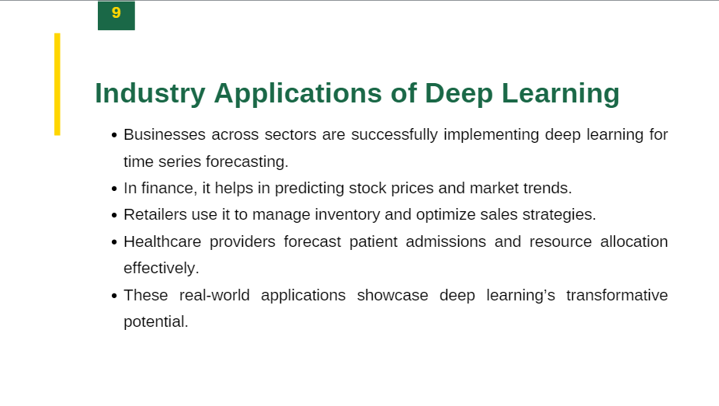

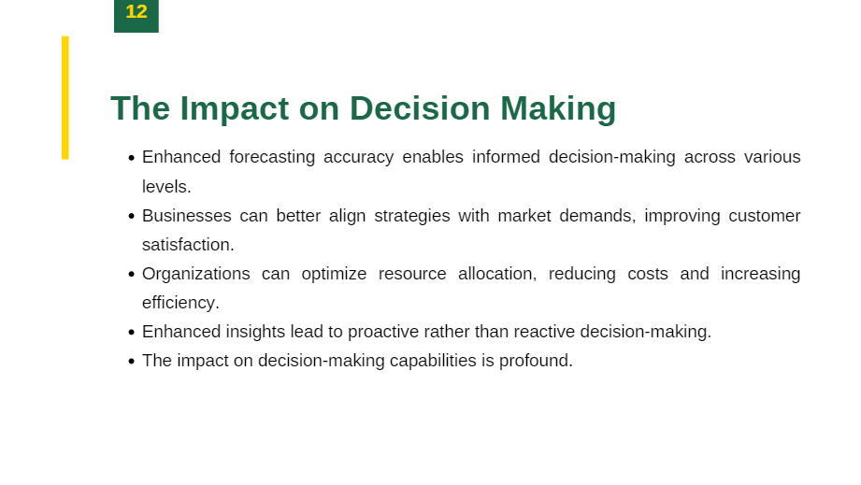

**3.2 )Rubrics for Pitch Presentation Evaluation (RBL 3)**

**Instructions:**

* Faculty should observe the performance of student as per given Rubric and put √ in appropriate box.
* At the end of table there is Remark section. Mention special observations if any by you there.
* In case student is getting excellent category then mention reason for selection along with marks in brief in last column.

|  |  |  |  |  |  |  |
| --- | --- | --- | --- | --- | --- | --- |
| **Group No.** | **Name of Team** | **Department and Domain** | **Name of student** | **Roll Number** | **Division** | **Sign** |
|  |  |  |  |  |  |  |
|  |  |  |  |
|  |  |  |  |

|  |  |  |  |  |  |
| --- | --- | --- | --- | --- | --- |
| **Sr. No** | **Description** | **Excellent**  **(20 Marks)**  **100 Percent** | **Very Good**  **(15 Marks)**  **75 Percent** | **Good**  **(10 Marks)**  **50 Percent** | **Average**  **(05 Marks)**  **25 Percent** |
| Introduction, Preparedness and organization  (GA2, GA 3, GA 10) | **1**.Strong and engaging introduction;  **2.**Draws the audience into presentation  **3**.Thoroughly prepared, well-organized, logical sequence of information that the listener could easily follow. | Exceeds Expectations | Meets Expectations | Meets Some Expectations | Does Not Meet Expectations |
| Subject Knowledge (GA1, GA2) | • Clear, thorough description of product or service.  • Communicates benefits and/or how product/services solve a problem. | Exceeds Expectations | Meets Expectations | Meets Some Expectations | Does Not Meet Expectations |
| Visual Aids/Materials  (GA4, GA5) | Correct spelling and grammar used on all handouts used to support the pitch (if applicable). | Exceeds Expectations | Meets Expectations | Meets Some Expectations | Does Not Meet Expectations |
| Persuasion (GA 6, GA 10) | Compelling pitch that successfully convinces listener/audience that the product or service is beneficial and why it is the best on the market. | Exceeds Expectations | Meets Expectations | Meets Some Expectations | Does Not Meet Expectations |
| Delivery and Time Management  (GA 10, GA 12) | * Effectively and creatively delivers pitch with eye contact and enthusiasm that engages the listener/audience. * Speaks clearly and distinctly. * Presentation is between 2-3 minutes, and was obviously rehearsed. | Exceeds Expectations | Meets Expectations | Meets Some Expectations | Does Not Meet Expectations |

Remark:-------------------------------------------------------------------------------------------------------------------------------------------------------------------------------------------------------------------------------------------------------------------------------------------------------------------------------------------------------------------------------------------------------------------------------------

GA 1: Engineering Knowledge GA 7: Environment and Sustainability

GA2: Problem Analysis GA 8: Ethics

GA3: Design/Development of solutions GA 9: Individual and Team Work

GA 4: Conduct Investigation of complex problems GA 10: Communication

GA 5: Modern Tool Usage GA 11: Life Long Learning

GA 6: The Engineer and Society GA 12: Project Management and Finance

Name and Sign of Faculty

**Chapter 4.** **Project Competition**

**4.2) Rubrics for Participation in Competition**

**Instructions:**

∙ Faculty should observe the performance of student as per given Rubric and put √ in appropriate box. ∙ At the end of table there is Remark section. Mention special observations if any by you there. ∙ In case student is getting excellent category then mention reason for selection along with marks in brief in last column.

|  |  |  |  |  |  |  |
| --- | --- | --- | --- | --- | --- | --- |
| **Group**  **No.** | **Name of Team** | **Department and Domain** | **Name of student** | **Roll**  **Number** | **Division** | **Sign** |
|  |  |  |  |  |  |  |
|  |  |  |  |
|  |  |  |  |

|  |  |  |  |  |  |
| --- | --- | --- | --- | --- | --- |
| **Parameter** | **Excellent**  **(20 Marks)**  **100 %** | **Very Good**  **(15 Marks)**  **75 %** | **Good**  **(10 Marks)**  **50 %** | **Average**  **(05 Marks)**  **25 %** | **Marks**  **%** |
| Problem  definition  GA 1,GA 2 | Problem is defined clearly and identifies underlying issues.  Scope is identified and finalized with features  innovative steps are taken | Problem is defined adequately  Scope is adequately identified and finalized with features | Problem is not defined appropriately  Scope is not identified appropriately and features are not fully finalized | Problem is not defined at all.  Scope is not identified a all and features are vague |  |
| **Functionality**  GA 4 | Product has very good chance of functioning 80%-100% functionality. | Product has good chance of functioning sufficing 60%-80% of functionality | Product has some chance of functioning with 30%-50% stake. | Product has very less chance of functioning |  |

|  |  |  |  |  |  |
| --- | --- | --- | --- | --- | --- |
|  |  |  | audience  knowledge level. | knowledge level. |  |
| **Design**  GA4,GA5 | The solutions has very good proficiency in using the elements and principles of design(Modularity, cohesion etc) with high level of creativity for the task. | The solution has good proficiency in using the elements and principles of design with good results for the task. | The solution has limited proficiency in using the elements and principles of design, but design is inappropriate for the task | No proficiency in using the elements and principles of design. |  |
| Implementation  GA 5,GA 6 | Use of Optimization, error handling techniques  Documentation of Implementation done  Use of tools e,g, Github, integration tools | error handling techniques  Moderate Documentation of Implementation  Use of tools e,g, Github | less  Documentation of Implementation  Use of tools e,g, Github | No error handling techniques  No Documentation of Implementation  No Use of tools e,g, Github |  |
| Potential for product conversion  GA 9, GA 12 | Develops a clear Solution and has high potential for product development | Solution is based on criteria with with good chances of product development | Analyses of some of the alternatives or constraints have lead to different recommendations with some chance of product development | Only one solution is considered with constraints and cannot be converted into product |  |

Remark:----------------------------------------------------------------------------------------------------------------------------------------------- ---------------------------------------------------------------------------------------------------------------------------------------------------------- -----------------------------------------------------------------------------------------------------------------------------------------------------

Name and Sign of Faculty:

|  |  |  |  |  |  |  |  |  |  |  |  |
| --- | --- | --- | --- | --- | --- | --- | --- | --- | --- | --- | --- |
| **GA1**  **Knowled**  **ge** | **GA**  **2**  **Pro**  **b**  **Ana**  **lysis** | **GA3**  **Inve**  **stiga**  **tion** | **GA4**  **Desig**  **n** | **GA5**  **Tools** | **GA6**  **Teamw**  **ork** | **GA7**  **CS** | **GA8**  **Professionali sm** | **GA9**  **Society** | **GA**  **10**  **Ethics** | **GA**  **11**  **FM**  **PM** | **GA**  **12**  **Life long**  **learning** |

**Chapter 5.** **Research Paper**

**5.2 Proof of Paper Submission:**

**5.3) Research Paper Presentation Rubric (RBL 3)**

**Instructions:**

* Faculty should observe the performance of student as per given Rubric and put √ in appropriate box.
* At the end of table there is Remark section. Mention special observations if any by you there. In case student is getting excellent category then mention reason for selection along with marks in brief in last column.

|  |  |  |  |  |  |
| --- | --- | --- | --- | --- | --- |
| **Topic**  **Organization of content**  **GA4 GA6** | Excellent (20)  If paper includes all heads including 1) abstract, 2) introduction, 3)objectives, 4)methodology, 5)experimental plan, 6)result and discussion, 7)conclusions, 8)future scope. | Very Good (15)  If paper includes any 7 topics out of 1) abstract 2) introduction, 3)objectives, 4)methodology, 5)experimental plan, 6)result and discussion, 7)conclusions, 8)future scope. | Good (10)  If paper includes any 5-6 topics out of 1) abstract, 2) introduction, 3)objectives, 4)methodology, 5)experimental plan, 6)result and discussion, 7)conclusions, 8)future scope. | Average (05)  If paper includes any 4 topics out of 1) abstract, 2) introduction, 3)objectives, 4)methodology, 5)experimental plan, 6)result and discussion, 7)conclusions, 8)future scope. | Marks |
| **Grammar and Format**  **(GA7)** | * The writing is   Compelling.   * Sentences are   well-phrased and varied in length and structure.   * Word choice is consistently   precise and  accurate. | * The writing is generally engaging,   but has some dry  spots.   * Sentences are well phrased and there is some variety in   length and structure.   * Word choice is   generally good. | * The writing is dull and un engaging. * Some sentences are awkwardly   Constructed so that the reader is occasionally distracted.   * Word choice is merely   adequate, and  the range of  words is limited. | * The writing loses interest   in the reader.   * Errors in   sentence  structure are  frequent  enough to be  a major  distraction to  the reader.   * Many words are used   inappropriate |  |
| **Design and**  **Implementation**  **(GA4, GA5)** | All 4 parameters met:  1) Modern Tool Usage  2) Feasibility  3)User friendliness  4)Application | Any 3 parameters met:  1) Modern Tool Usage  2) Feasibility  3)User friendliness  4)Application | Only 2 parameters met:  1) Modern Tool  Usage  2) Feasibility  3) User  friendliness  4)Application | Only 1 parameter  met:  1) Modern Tool  Usage  2) Feasibility  3)User |  |
|  |  |  |  | friendliness  4)Application |  |
| **Presentation and Team**  **Work**  **(GA6, GA7)** | * Student   demonstrates full  knowledge,  answering all  queries with  explanations.   * Movements seem smooth and help the audience   visualize.   * Diverse talents are present in team with different skill set | * Student is at ease with information and answers all queries without elaboration. * Made movements or gestures that enhance articulation. * Team is concentrated with only one type of skill set. | * Student is   Uncomfortable with  information and is able to answer only basic queries.   * Very little   movement or descriptive  gestures.   * Team members are not contributing much for multifaceted development of idea | * Student does not have grasp of   Informationand  can’t answer  queries about subject.   * No movement or descriptive gestures. * Team   members are passive only   * one person is take some efforts |  |
| **Quality of**  **publication (GA10,**  **GA11)** | If student have published paper in Peer Reviewed Quality Journal | If student have published paper in International/ National Journal | If student have published paper in International  Conference | If student have published paper in National  Conference |  |

**Remark:-------------------------------------------------------------------------------------------------------------- ------------------------------------------------------------------------------------------------------------------------**

**Name and Sign of Faculty:**

|  |  |  |  |  |  |  |  |  |  |  |  |
| --- | --- | --- | --- | --- | --- | --- | --- | --- | --- | --- | --- |
| **GA1** | **GA2** | **GA3** | **GA4** | **GA5** | **GA6** | **GA7** | **GA8** | **GA9** | **GA**  **10** | **GA**  **11** | **GA**  **12** |
| Kno  wled  ge | Prob  Analysis | Investigati  on | Desi  gn | Tools | Tea  mwo  rk | CS | Profes  sionali  sm | Societ  y | Ethics | FM  PM | Life long  learning |

**Chapter 6. Research Outcome Achieved**

**6.1 Screenshot of Research Outcome Quiz:**

